**Testing**

Task: Account Create

Non-registered user has to create a new profile to make purchase or register as a trader.

Steps:

* He/she will open our website in his/her device
* New user will go to **login** page
* New user will click **Register**
* User will enter required details in Registration Form
* User will click on Work as Trader if he wants to register as trader
* Email is validated using a email validation mail which will be sent to the given mail
* If verified new user is registered successfully and browse products

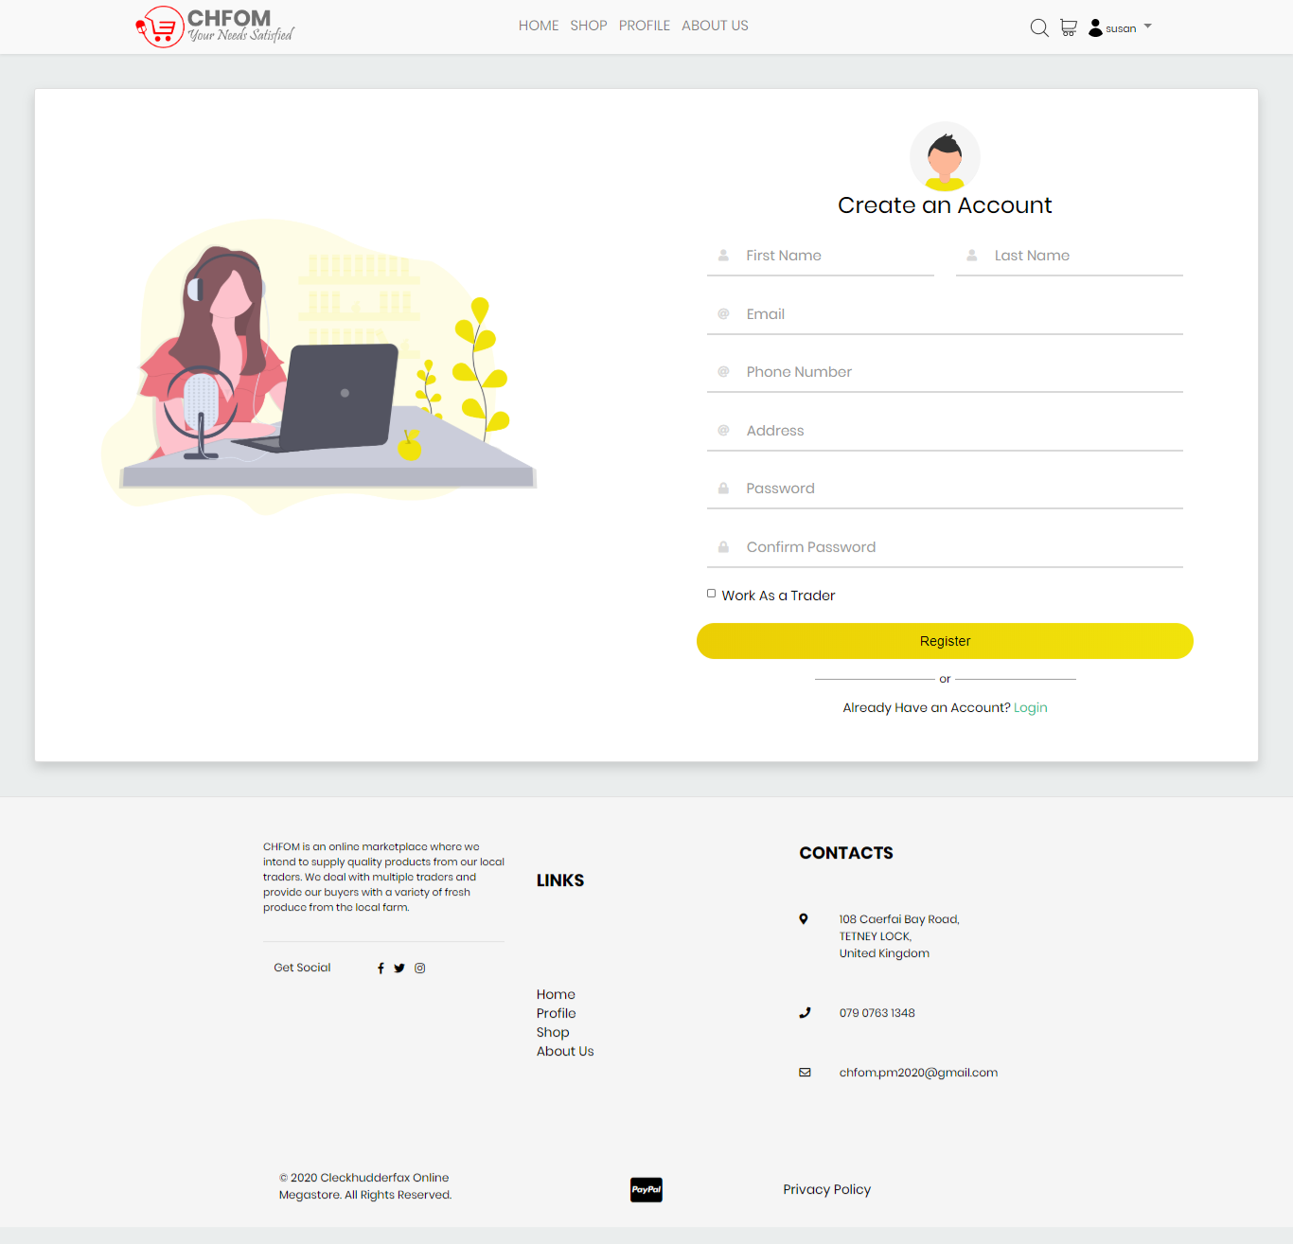

Task: Email Verification

Newly registered user or trader is verified via Email

Steps:

* When registered a mail is send to existing email address
* User have to open his/her mail
* He will receive a mail from Cleckhudderfax Online Megastore (CHFOM)
* Thank you for registration message will be displayed
* Click on Verify Email Now
* New user is verified

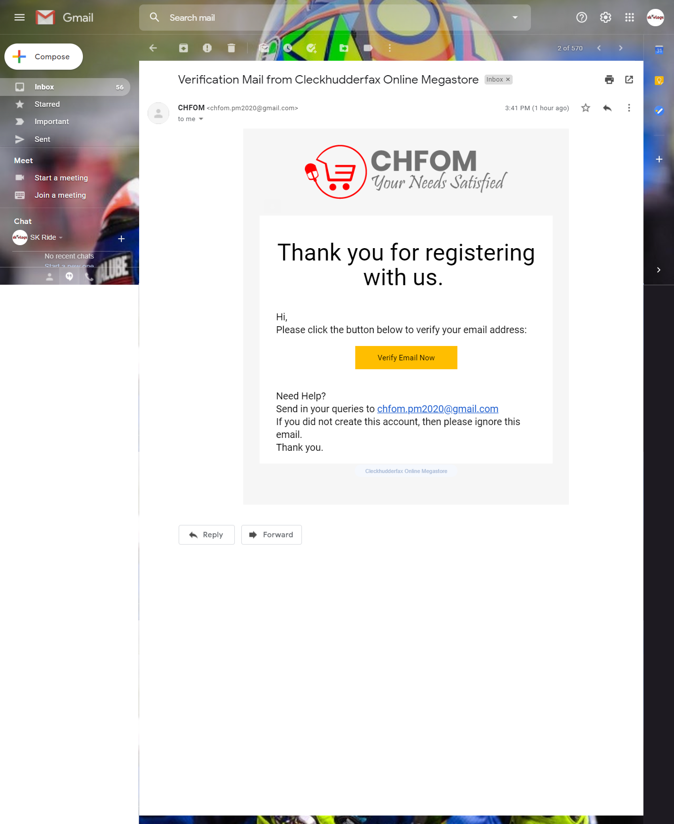

Task: Email Already in Use

While registering we might face a problem having email already being used in our website.

Steps:

* User click on login page
* User click on registration
* User fill required information in registration form
* User click on register button
* A message “Email is already used” is displayed

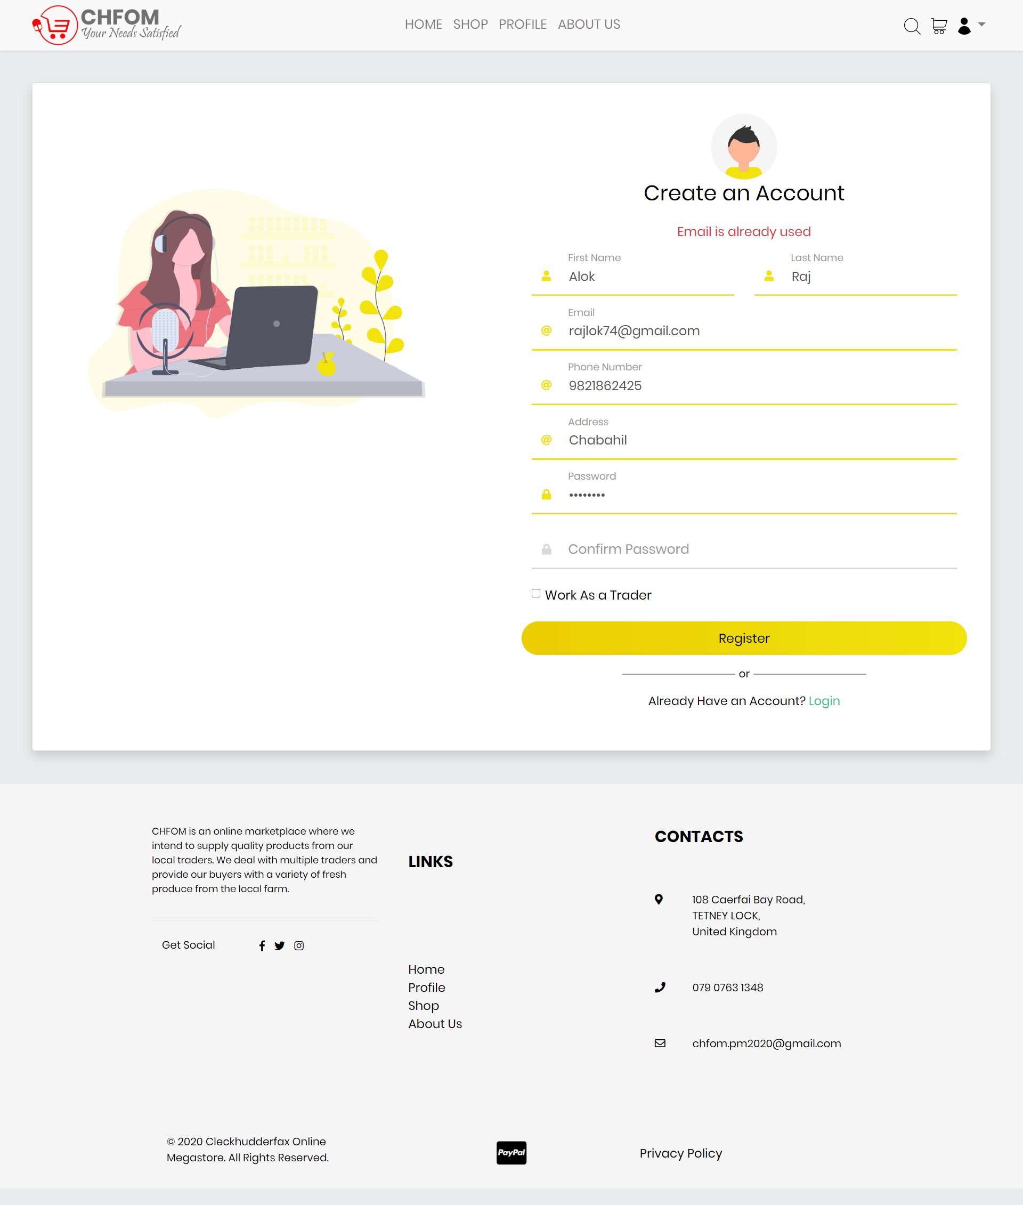

Task: Login to registered profile

Susan Khatri is a verified registered customer and wants to login to our website

Steps:

* Susan Khatri opens our website
* Susan Khatri clicks on login
* Susan Khatri enters his details
* Susan Khatri clicks on sign in
* Instant validation is done
* Susan Khatri is now logged in

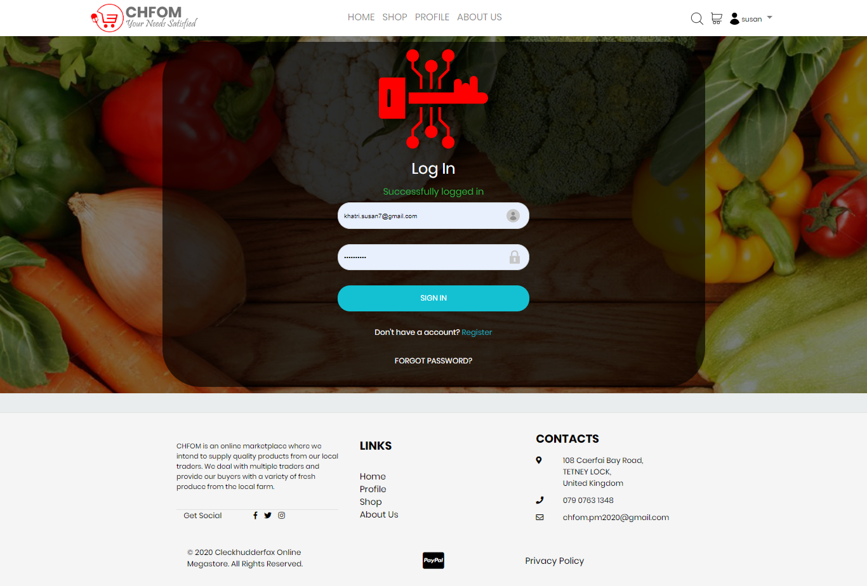

Task: Invalid Email address in login page

When signing in, this is what happens when user enter invalid or wrong email address

Steps:

* User open our website
* User click on login page
* User enter required details
* User click on Sign Up button
* If invalid, message “No user with given email exists” is displayed

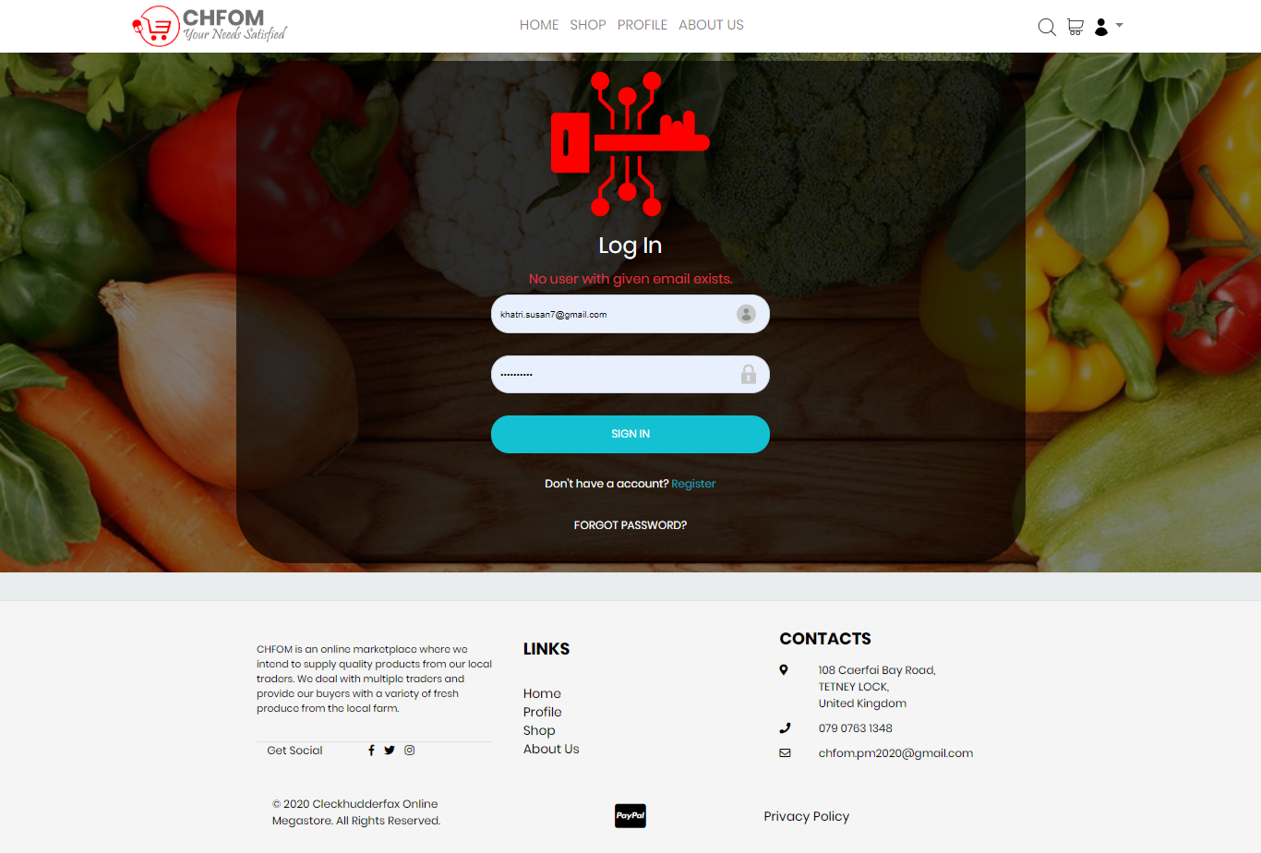

Task: Wrong Password in Login Page

When user enters our website and tries to login but make password incorrect

Steps:

* User opens our website
* User click on login
* User enters required details in login page
* User clicks on sign up
* Password gets wrong
* Message written “Password Incorrect” is displayed

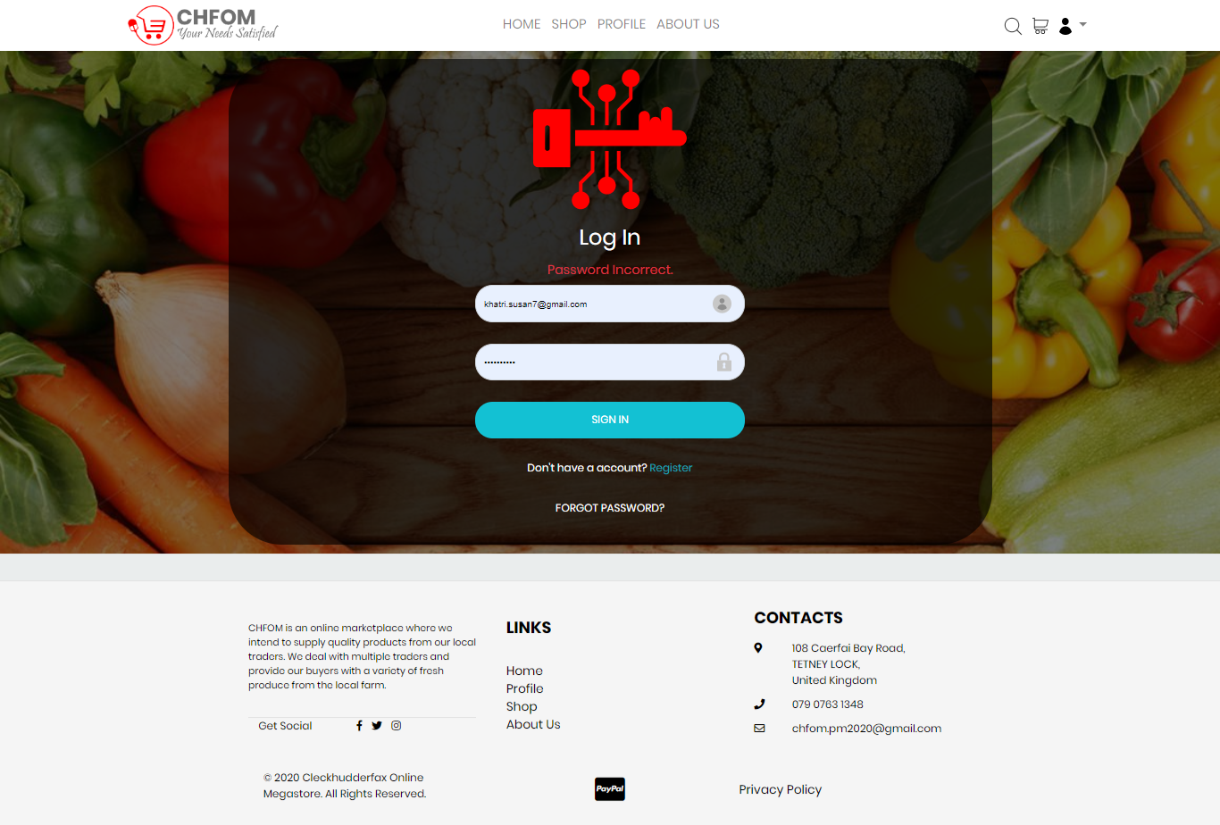

Task: Reset Password

When user forgets his password he/she can reset it verifying via their emails

Steps:

* User opens our website
* User click on login
* User tries to access but forget his/her password
* User click on option “Forget Password”
* New reset form is displayed
* User have to enter his/her email address
* Verification is done via email
* User is redirected to a new page where user can enter their new password
* User can now login

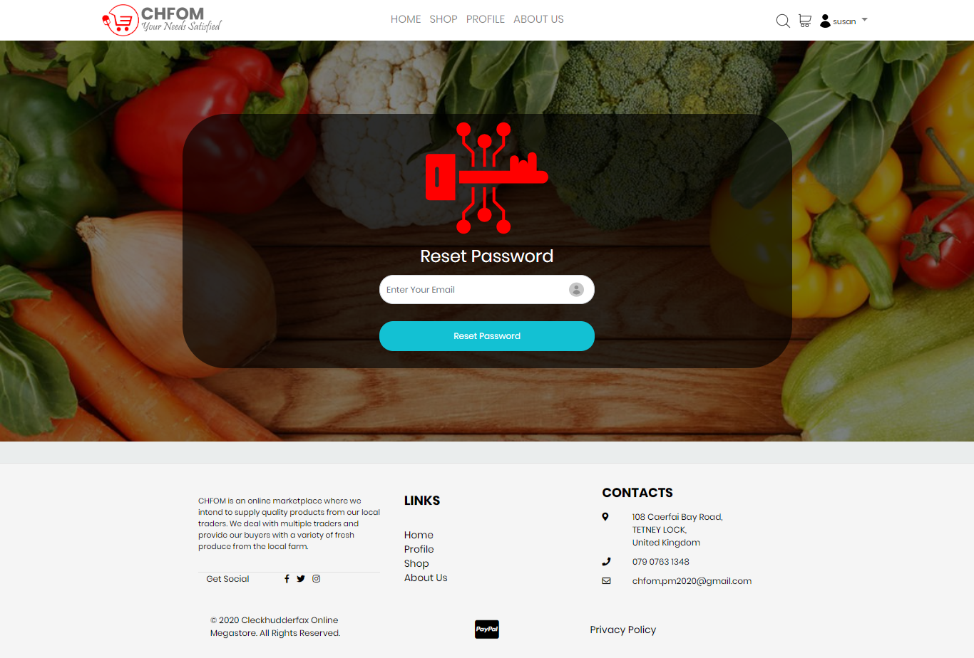

# Task: Edit Profile

The user can edit and update his/her profile as he like.

Steps:

* User cannot edit their email address
* User can edit Full Name
* User can edit Address
* User can click on cancel to discard changes
* User can click on save changes to save the changes

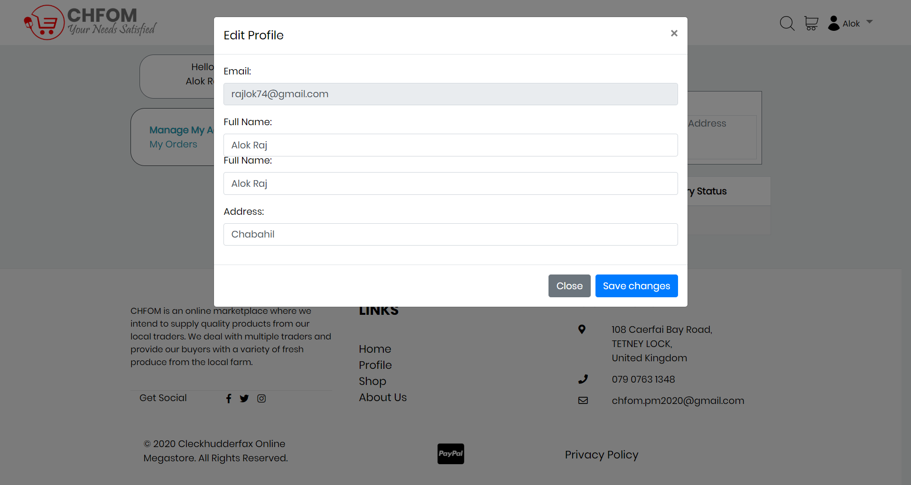

Task: Filter Shop

Customer can filter the products to look for products of same category and it is easier than going through every product.

Steps:

* User visit home page of our website
* User will click on Shop
* On left and side there is a slider click on it
* User can click whose product they are interested in as categorized
* Related products are shown at the screen
* User can also sort the shown goods

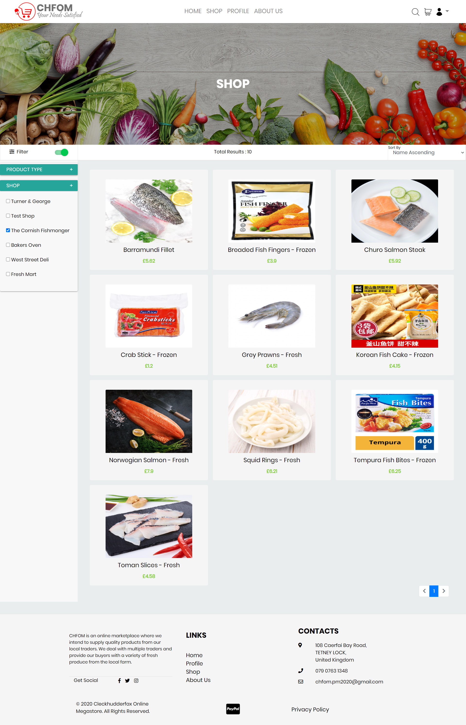

Task: Search Result

We can simply search for what we are looking for from search option in navigation bar.

Steps:

* User enters into our home page from their browser
* User click on search icon on navigation bar
* Search bar is displayed and we can type what we are looking for
* Typing the name of product result in displaying particular product

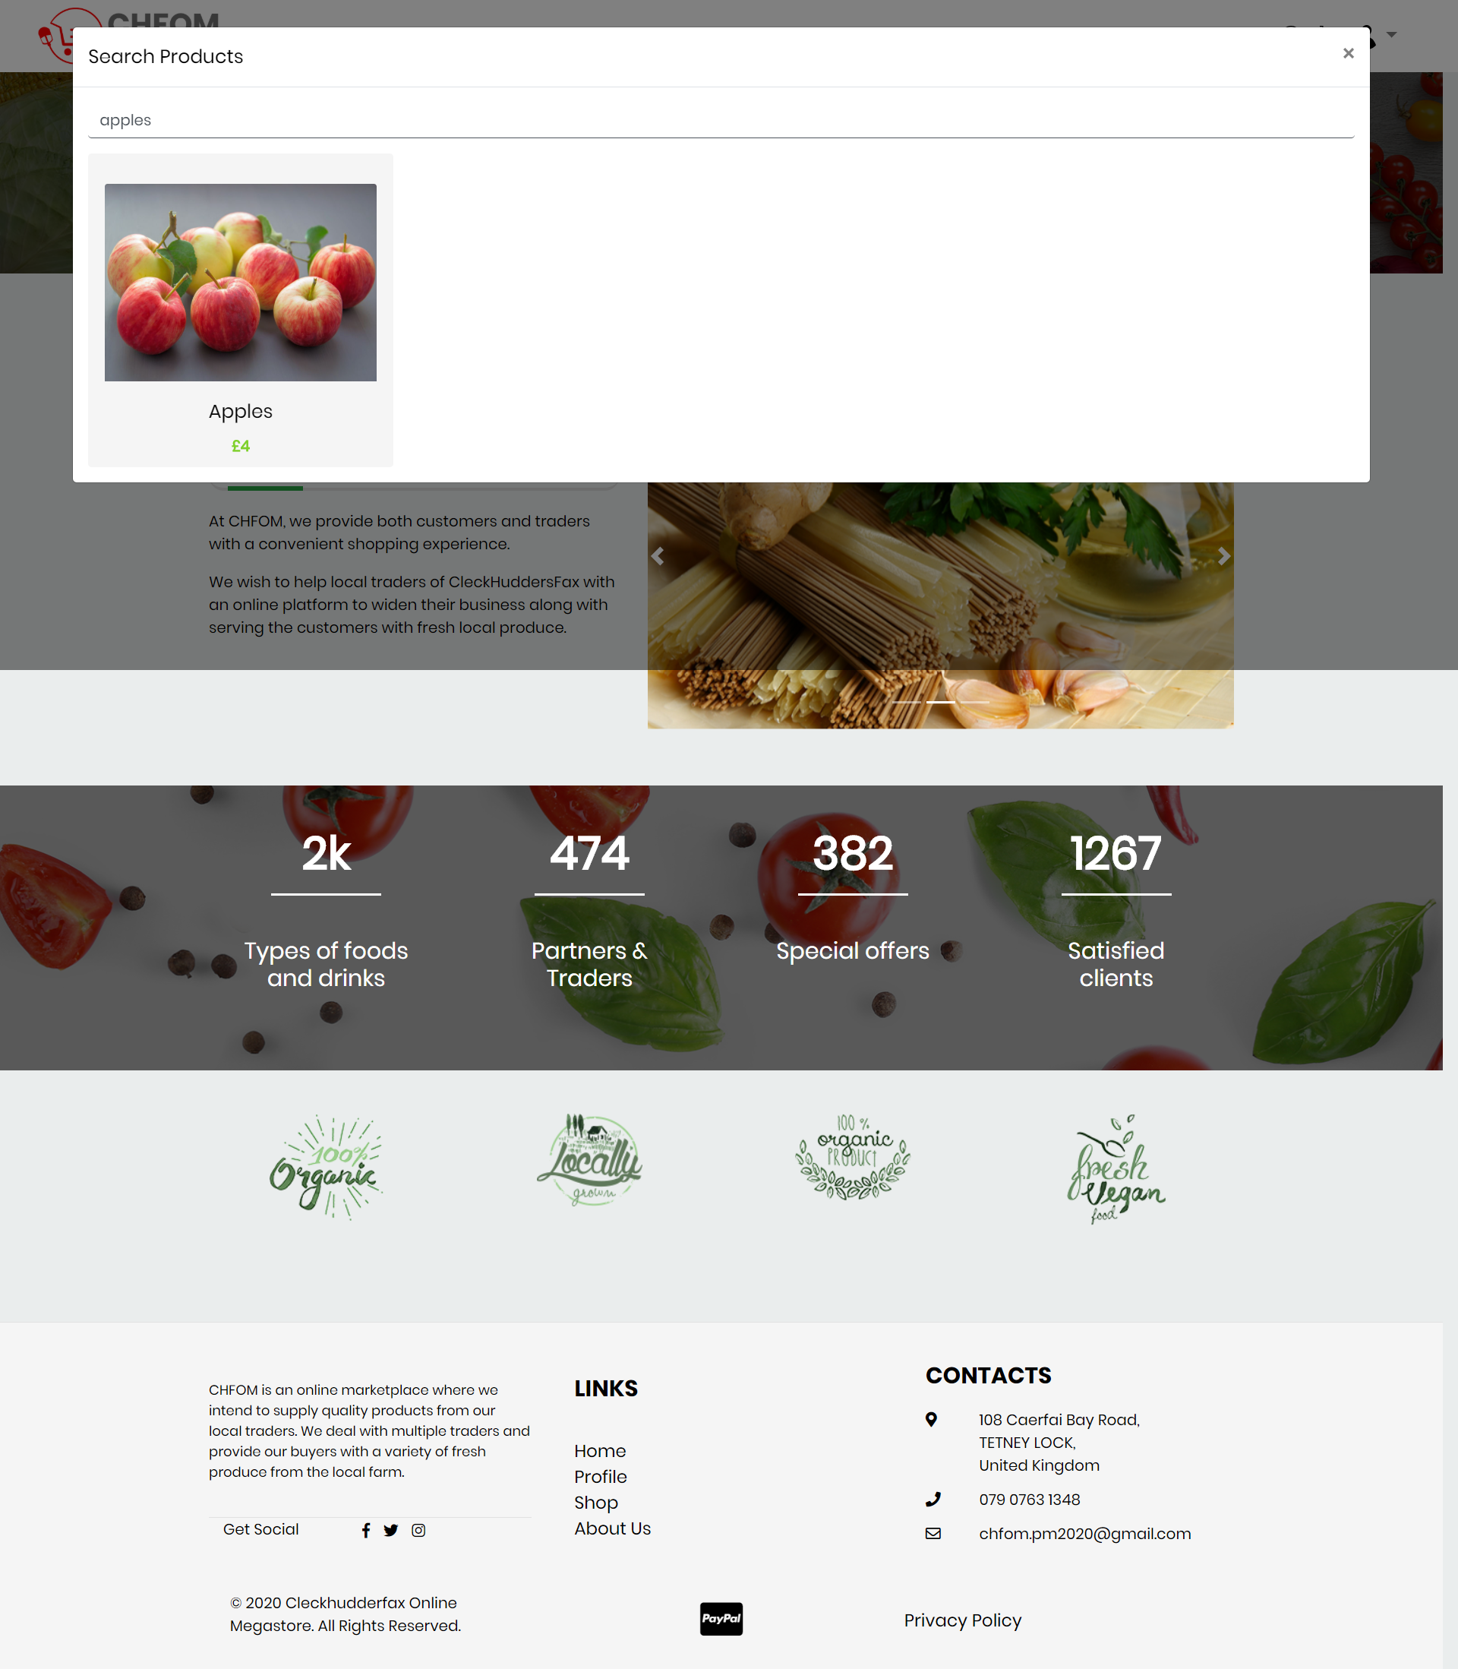

Task: Add to Cart

When a user start shopping he will not be buying one product after another he will be determined to add all product in one and grand total all to save time.

Steps:

* User open our website in their devices
* User login via login page
* User can see products
* User can filter products to assemble product systematically
* User can click on product and get detail information
* User can even rate products
* User can give reviews and feedbacks
* User can edit quantity as he like
* User can update basket which will add it to cart
* User can remove them from basket too

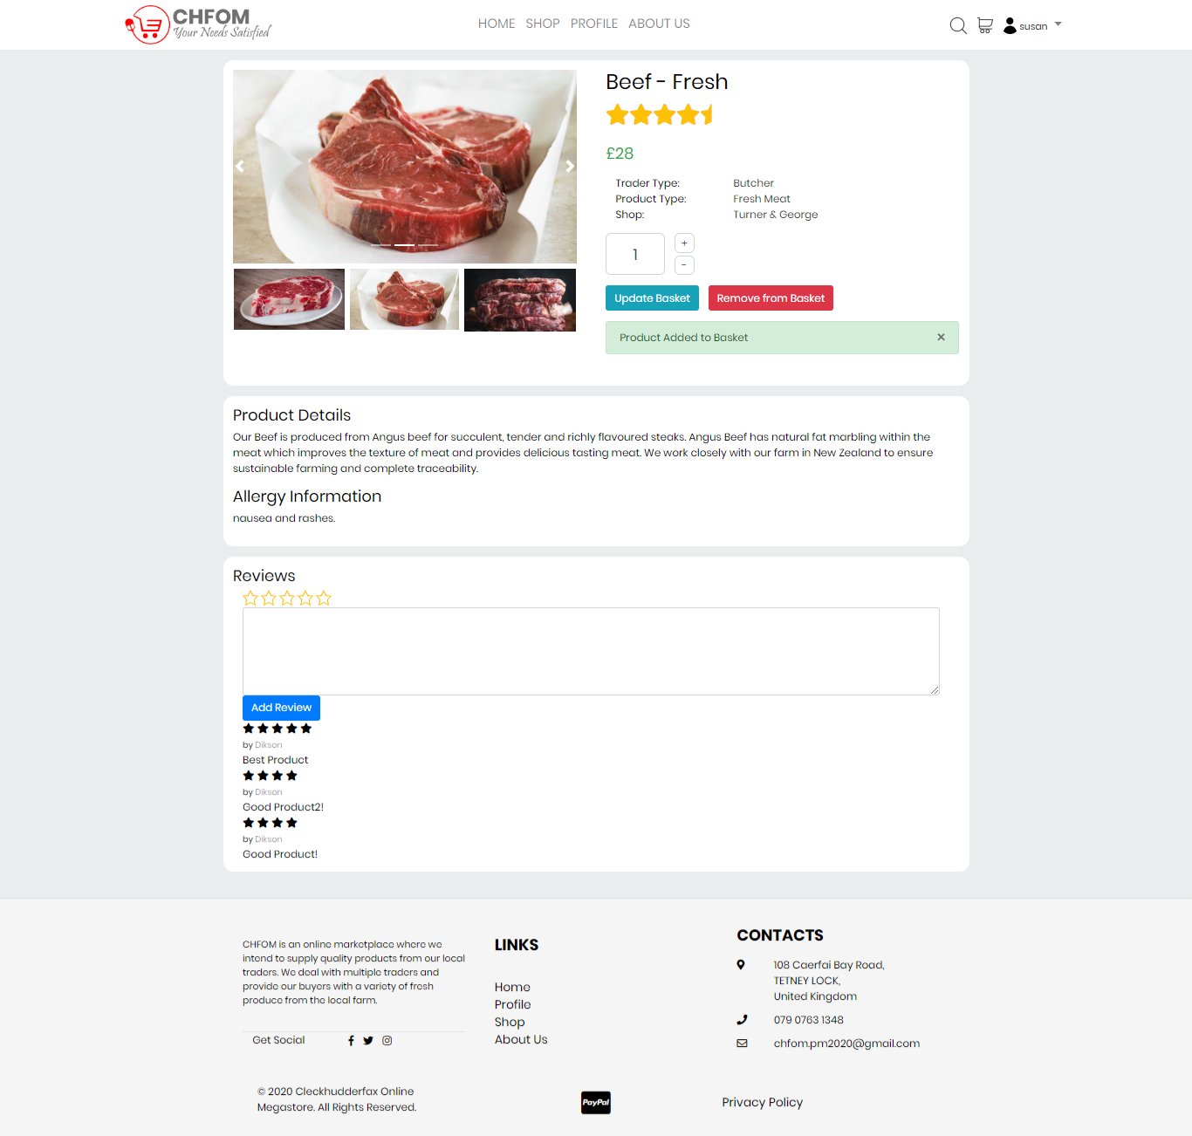

Task: Edit Basket

Once user add product to cart a new page is displayed which we call basket where we can see what products we have added

Steps:

* User login via login page
* User views product
* User click on update basket to add product to cart
* Cart page is opened
* Product list along with price, quantity and subtotal is displayed
* User have option to remove product from cart
* User can see collection due date
* User can checkout to process for payment
* User can even continue shopping if he needs to add more products

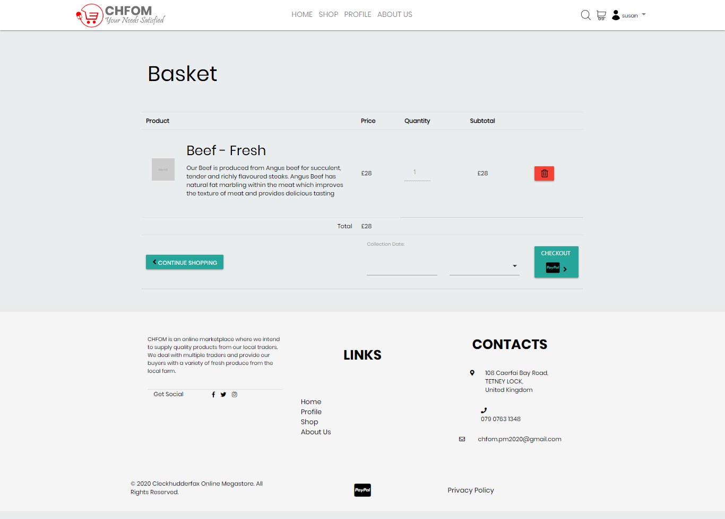

Task: Delivery Date

As our website only deliver in three days so it’s too important to have collection date set so that user don’t miss it out.

Steps:

* User edit basket
* User can edit collection date
* User can click on checkout to go to payment process

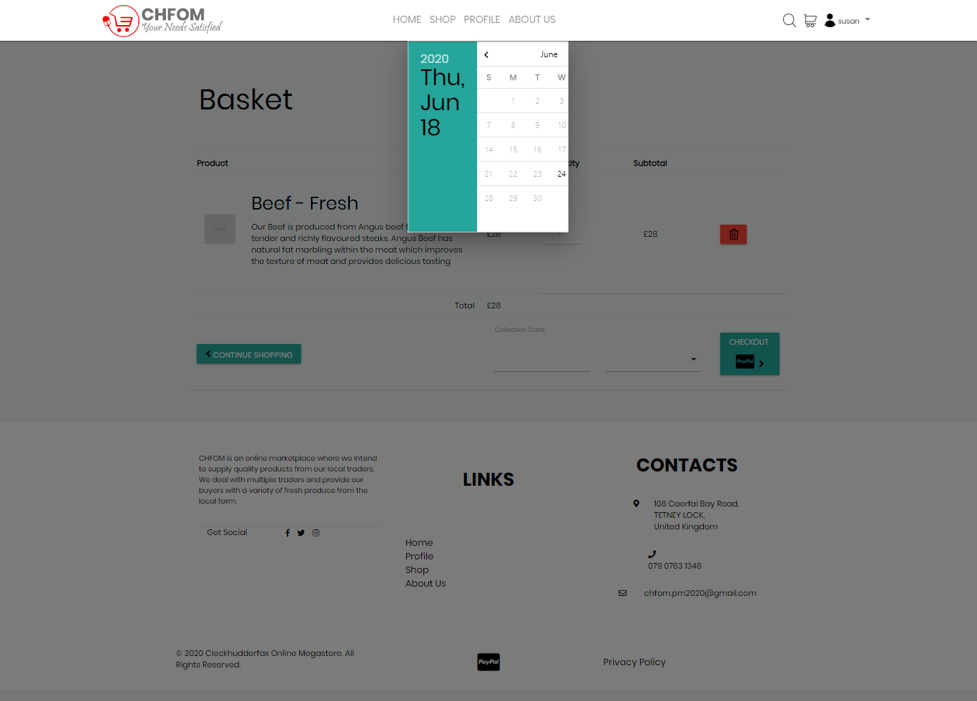

Task: Payment phase 1

When collection date is set then payment page opens up and user start processing.

Steps:

* User gets into payment processing page
* User gets three ways to pay i.e. PayPal, National Australian Bank and Visa
* User also can link his/her card

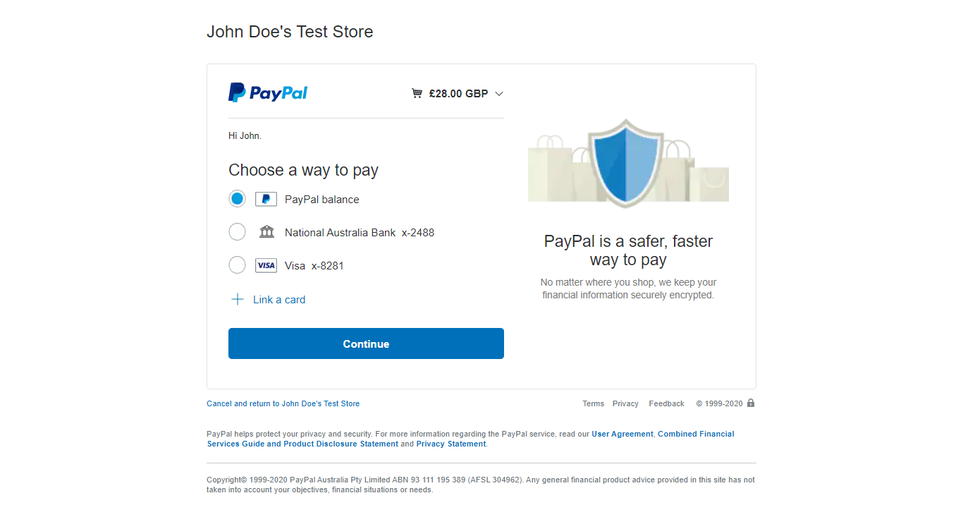

Task: PayPal option is selected

When user clicks on PayPal option he/she enters into another page and details have to be filled.

Steps:

* User select PayPal balance option from payment page.
* User enters into another page where total cost of purchase is shown along with PayPal balance
* User can view where the product is shipping and change it
* User can have option to make PayPal his/her preferred way to pay
* User can cancel and return back to trader
* User can click on Pay Now

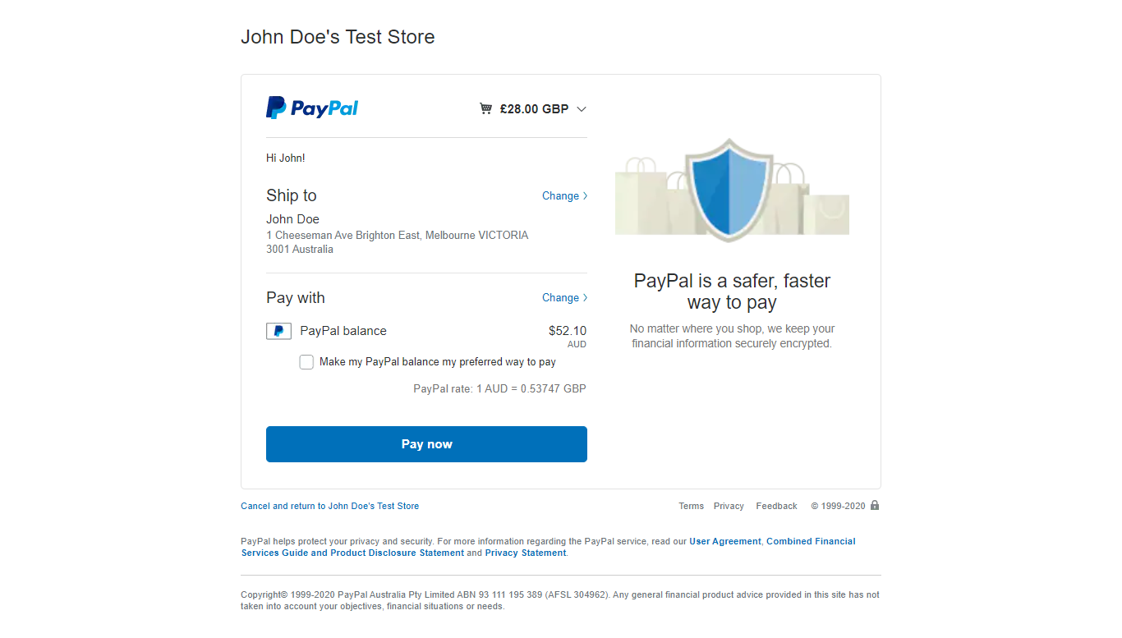

Task: Payment Successful

When the details are filled and pay now is clicked user receive a successfully paid invoice in his/her email

Steps:

* User click on Pay Now
* User receives mail of completed payment via email
* Click Here option is there to redirect to trader if not materialized

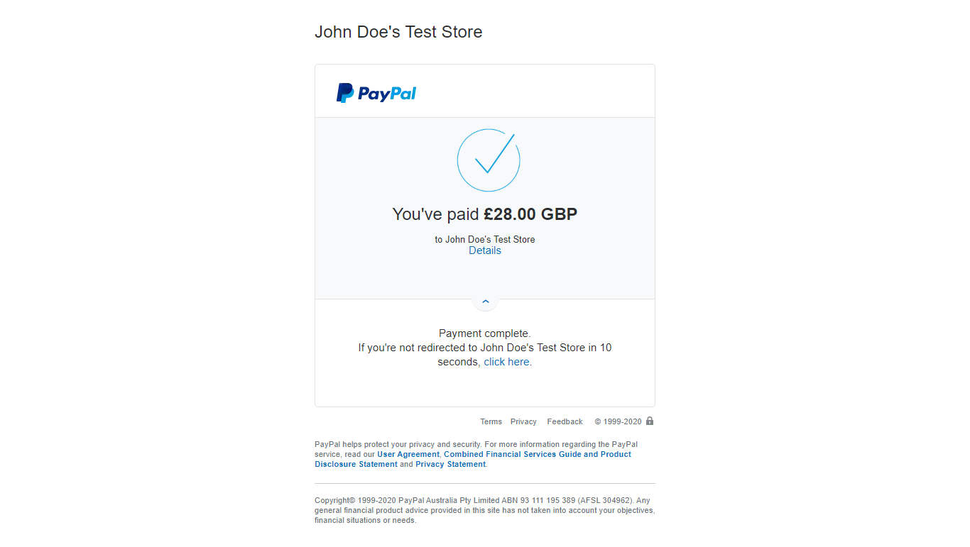

Task: Order Receipt

Invoice is send to customer by Cleckudderfax Online Megastore via Emails to each and every customer

Steps:

* Customer have done all the payment process
* Billing of all the transaction is automatically sent to customer as well as admin by traders themselves
* Customer and admin can view the invoice via their mail
* Invoice contain total amount, billing address and transaction ID on it

